A Standard GA Approach to Native Protein Conformation Prediction
Arnold L. Patton, W. F. Punch III, E. D. Goodman
Proceedings of 6th International Conference on Genetic Algorithm, 1995
- Introduction
1.1 Problem description
1.2 Preceding work
1.3 Domain Model
1.4 Hybrid GA approach
- Implementation
2.1 Domain Model Modification
We modify the model slightly, penalizing for positional collision, rather than simply discarding individuals having illegal states.
2.2 Encoding
2.3 Objective function
Note the following about this evaluation function:
- each contact gives a 2 point value
- adjacent hydrophobes in the protein’s primary sequence are not discounted in the scoring
- multiple collisions ct a single point results in only a single penalty
- hydrophobe collisions carry an implied addition penalty since no contacts ae scored for collided hydrophobes
2.4 Algorithm implementation
2.5 Parameter tuning
- Generalized score & testing
3.1 Generalized report value
The maximal potential value for a given sequence will be a fixed value ranging from 0 to 2.0.

3.2 Generalized test sequences
We have created a series of test sequences for which the minimum configuration may be directly calculated. This series of “looped cubes” also allowed us to test the effectiveness of the approach on several different types of possibly difficult sequences.
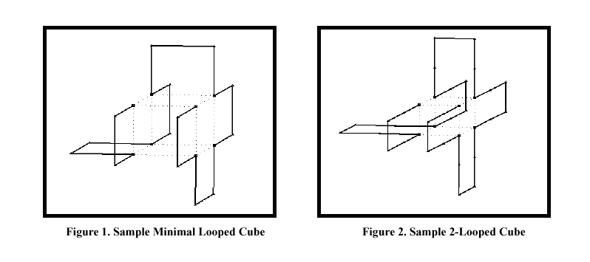
- Results
See Table 1
Created by: Yi-Ying Chen
Date: Oct. 9, 2001

